Token Economy Assignment – Major Assignment #2
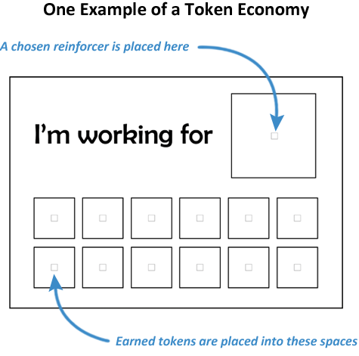
The token economy assignment is designed to give you the chance to put your understanding of behavioural psychology into practice. It is also your chance to be, in Sheldon’s words, “…applying a harmless scientifically valid protocol that will make [your] lives better…”
The project will have you select a behaviour you want to change and create a token economy for yourself. You choose the desired behaviour as well as the reinforcer that you will use. You will be using a fixed ratio schedule but you will decide upon the number of correct responses that need to be achieved before reinforcement. You will collect data on your progress for at least six weeks and then you will submit your data and your analysis of the data on June 15th.
There will be time in class to work on your analysis - the analysis will only be started after data collection is completed.
You will want to select an appropriate reinforcer. Food can be great reinforcers but the reinforcer doesn’t have to be food. This should be something that you typically don’t have access to and that you enjoy/find pleasurable.
Example
Target behavior: Sleeping eight hours a night
Reward: One bunch of cut tulips
Fixed Ratio Schedule: Every fourteen days that I sleep at least eight hours in one night
Data tracking: I will put an X each night that I sleep eight hours or more.
March 16 | March 17 | March 18 | March 19 | March 20 | March 21 | March 22
X |  | X |  |  |  | X
 | Rebecca up early |  | Up late cleaning | Up late cleaning | Up late cleaning
March 23 | March 24 | March 25 | March 26 | March 27 | March 28 | March 29
X | X | X | X | X | X | X
March 30 | March 31 | April 1 | April 2 | April 3 | April 4 | April 5
X |  | X | X | X | X
 | Insomnia |  |  |  | Get flowers!!!! | Marking
Whether you are successful or not has no bearing on your grade!!!
Target behavior:

Reward:
Fixed Ratio Schedule:
Data tracking:
March 16 | March 17 | March 18 | March 19 | March 20 | March 21 | March 22
March 23 | March 24 | March 25 | March 26 | March 27 | March 28 | March 29
March 30 | March 31 | April 1 | April 2 | April 3 | April 4 | April 5
April 6 | April 7 | April 8 | April 9 | April 10 | April 11 | April 12

